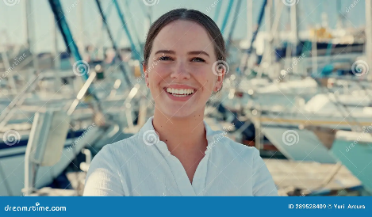**Cindy Wells**

**“I love working with customers who share a passion for sailing!”**

Bio: Cindy is passionate about sailing; her father would take her out on the water ever since she was a kid. She loves helping others enjoy the sea by providing maritime services at the marina.

Demographics

* White
* Female
* Single
* $73,000 a year income

Personality traits:

* Outgoing
* Empathetic

Motivations:

* Providing services that help her clients achieve their dream life on the water.
* Loves deep-sea fishing and sharing tips and fishing spots with local anglers.

Goals and Frustrations:

* Wants to be able to access slip availability to provide prompt customer service to new clients.
* Is frustrated by larger slips being leased to smaller crafts. Wants customers to be transferred to smaller slips when they become available so the larger slips are available to customers with large vessels.

Tech skills:

* Has a work smartphone that allows her to handle requests from customers while out of the office.
* Most of her work is done on a laptop from the office.
* Is fairly computer literate but does not consider herself tech savay.

Work responsibilities.

* Works directly with customers to provide slip leasing and marina services.
* Creates user accounts for new customers
* Recommends additional services based on customer needs